 

**INSTITUTE FOR ADVANCED COMPUTING**

**AND SOFTWARE DEVELOPMENT (IACSD),**

**AKURDI, PUNE**

Documentation On

Online Book Store

(bookstack.com)

PG-DAC March 2023

# Submitted By:

# Group No: 71

**Roll No. Name:**

**233153 Ganesh Gaikhe**

**233150 Dhanraj Chavan**

**Mrs. Manjiri Deshpande Mr. Rohit Puranik Project Guide Centre Coordinator**

**ABSTRACT**

The Online Bookshop web application is designed to offer comprehensive solutions for bookshop owners and customers through a single online platform.

It enables bookshop owners to efficiently manage their inventory, while customers can explore available books and make online bookings for their preferred titles. The administrator module oversees branch activities, bookshop operations, author, and genre management, and facilitates seamless notifications.

This project aims to empower bookshop owners by extending their business into the online realm, simplifying customer interactions, and reducing the administrative burden associated with paper-based record-keeping. Customers and authors can also receive notifications via email for updates and promotions.

The Online Bookshop System simplifies bookshop operations, enhances the customer experience, and creates a convenient online platform for book enthusiasts to discover and enjoy their favorite reads.

Top of Form

**ACKNOWLEDGEMENT**

I take this occasion to thank God, almighty for blessing us with his grace and taking our endeavour to a successful culmination. I extend my sincere and heartfelt thanks to our esteemed guide, **Mrs. Manjiri Deshpande** for providing me with the right guidance and advice at the crucial juncture sand for showing me the right way. I extend my sincere thanks to our respected **Centre**

**Co-Ordinator Mr. Rohit Puranik** for allowing us to use the facilities available. I would like to thank the other faculty members also, at this occasion. Last but not the least, I would like to thank my friends and family for the support and encouragement they have given me during our work.

**GANESH GAIKHE (223153)**

**DHANRAJ CHAVAN (223150)**

**Table o­­­­f Contents**

|  |
| --- |
| **INTRODUCTION**  **1.1. PROBLEM STATEMENT…………….…………………………..…..06**  **1.2. AIM & OBJECTIVES…………………………………………………07** |
| **OVERALL DESCRIPTION………………………………………………...08**  **REQURIMENTS**  **3.1 FUNCTIONAL REQUIREMENTS………..………………………….10**  **3.2 NON-FUNCTIONAL REQUIREMENTS…………………………....13**  **3.3 BACKEND………………………………………………………………14**  **3.4 FRONTEND…………………………………………………………….14**  **SYSTEM DIAGRAM**  **4.1 ACTIVITY DIAGRAM………………………………………………...15**  **4.2 DATA FLOW DIAGRAM……………………………………………..17**  **4.3 CLASS DIAGRAM……………………………………………………..19**  **4.4 USE CASE DIAGRAM…………………………………………………20**  **4.5 ER DIAGRAM………………………………………………………….24**  **4.6 SEQUENCE DIAGRAM……………………………………………….26**  **TABLE STRUCTURE……………………………………………………….**  **5.1 USER…………………………………………………………………….27**  **5.2 ADDRESS……………………………………………………………….27**  **5.3 CATEGORY…………………………………………………………….27**  **5.4 BOOK……………………………………………………………………28**  **5.5 CART……………………………………………………………………28**  **5.6 ORDERS………………………………………………………………...28**  **5.7 REVIEW………………………………………………………………...29**  **SCREENSHOTS………………………………………………………………………..30**  **CONCLUSION………………………………………………………………38**  **REFERENCE………………………………………………………………...39** |
|
|
|
|
|
|

**LIST OF FIGURES**

**FIGURE 1: ACTIVITY DIAGRAM(ADMIN)…………………….15**

**FIGURE 2: ACTIVITY DIAGRAM(USER)……………………….16**

**FIGURE 3: 0 LEVEL DFD………………………………………….17**

**FIGURE 5: 1 LEVEL DFD FOR ADMIN………………………….17**

**FIGURE 6: 1 LEVEL DFD FOR USER……………………………18**

**FIGURE 9: CLASS DIAGRAM…………………………………….19**

**FIGURE 6 USE CASE DIAGRAM ADMIN………………………20**

**FIGURE 9: USE CASE DIAGRAM USER………………………..21**

**FIGURE 8 USE CASE DIAGRAM DELIVERY PERSON………22**

**FIGURE 8 USE CASE DIAGRAM GUEST USER……………….23**

**FIGURE 8: E-R DIAGRAM ……………………………………….24**

**FIGURE 11: SEQUENCE DIAGRAM……………………….……..26**

**1.INTRODUCTION**

Welcome to the Online Bookstore project, a web-based application built on Spring Boot, ReactJS, and MySQL. This project aims to provide an intuitive and user-friendly online platform for customers to browse, purchase, and review books, while also providing the necessary functionalities for admin and delivery personnel.

The project utilizes Spring Data JPA, a powerful tool for working with databases, to enable seamless integration with the MySQL database. The application also leverages Axios, a popular HTTP client library for React, to facilitate efficient communication between the frontend and backend.

The application has a user-friendly interface that allows customers to register and log in with ease. Once logged in, customers can browse through the available books, add them to their cart, and checkout securely. In addition to making purchases, customers can also provide reviews and ratings for the books they have purchased.

The Online Bookstore project also includes separate login functionalities for admin and delivery personnel. Admins have access to the backend of the application, where they can add new books, manage orders, and view customer reviews. Delivery personnel can view their assigned orders and update their status as they are completed.

Overall, the Online Bookstore project aims to provide an intuitive and efficient platform for customers to browse, purchase, and review books, while also enabling the necessary functionalities for admin and delivery personnel to manage and fulfill orders.

**Problem Statement:**

In the traditional book retail industry, customers face several challenges. Many bookstores operate only physically, limiting the accessibility of books to a local clientele. Customers must visit multiple stores or rely on limited selections. There is also a lack of personalized recommendations, making it difficult for readers to discover new books tailored to their interests. Managing book inventory and sales manually can be cumbersome for bookstore owners, leading to inefficiencies and potential revenue loss. Additionally, readers often lack a platform for connecting with other book enthusiasts or accessing in-depth book information beyond what is on the book cover.

**Solution Description - Bookstack.com:**

Bookstack.com aims to address these challenges by providing a comprehensive online bookstore solution:

1. **Extensive Book CatLog:** Bookstack.com offers an extensive catalogue of books from various genres and authors, ensuring that readers have access to a diverse selection of reading materials.
2. **Online Accessibility:** Customers can browse, search, and purchase books from anywhere with internet access, eliminating the need to visit physical stores.
3. **User-Friendly Interface:** The website offers a user-friendly interface that allows customers to easily search, filter, and discover books of interest.
4. **Personalized Recommendations:** Bookstack.com employs recommendation algorithms that analysed customer preferences and browsing history to suggest books tailored to each user's taste.
5. **Secure Transactions:** The platform ensures secure online transactions, protecting customer data and financial information.
6. **Inventory Management:** For bookstore owners, Bookstack.com provides tools for efficient inventory management, tracking sales, restocking, and updating book information.
7. **Community Engagement:** Users can engage with a community of book enthusiasts through reviews, ratings, discussions, and author interviews, fostering a sense of belonging and enhancing the reading experience.
8. **Author and Book Information:** The website offers comprehensive author profiles, book summaries, and other supplementary information to help readers make informed choices.
9. **Convenient Access:** Readers can access their purchased books digitally or opt for physical copies, offering flexibility in reading preferences.
10. **Business Growth:** Bookstack.com aims to support bookstore owners in expanding their online presence, reaching a broader audience, and increasing sales through digital channels.

In conclusion, Bookstack.com is designed to provide an innovative online platform for book enthusiasts, addressing the limitations of traditional book retailing and fostering a thriving reading community while supporting the growth of online book businesses.

**Aims and Objective:**

Bookstack.com seeks to provide a user-friendly and secure platform for book enthusiasts to discover, purchase, and enjoy a wide range of books while also facilitating the growth of online book businesses.

In other words, our online book shop has, following objectives:

* Simple database is maintained.
* Easy operations for the user and the admin of the system.
* User interfaces are user accommodating and attractive; it takes very less time for the operator to use the system.
* Accessible Book Purchases: Bookstack.com aims to provide a convenient platform for individuals who prefer buying books online, making a wide range of books accessible to them at their fingertips.
* Efficient Search and Browsing: The objective are to maintain a well-organized and extensive database of books, making it easy for users to search, browse, and discover books of their interest quickly and efficiently.

**2. OVERALL DESCRIPTION**

**Proposed Methodology:**

Bookstack.com streamlines communication and business in the B2C field, offering comprehensive functionality for bookstore administrators (shopkeepers). This system allows admin managers to oversee users and the entire application, manage books, and empowers customers to search for books easily.

Bookstack.com is designed to enhance the reading experience by providing an extensive collection of books and facilitating access to literary resources.

Our system offers a user-friendly platform where readers can effortlessly search for books and access real-time updates about their favourite authors, new releases, and literary events.

The system is designed for efficient management of various tasks, including categorizing books, managing inventory, and processing payments. It also digitally tracks reading activities, provides insights into reading trends, and centralizes all book-related information on a single platform.

In summary, Bookstack.com is a dynamic online bookstore that simplifies the interaction and business processes in the B2C sector, catering to both administrators and book enthusiasts, while promoting the joy of reading and literary exploration.

**OPERATING ENVIRONMENT:**

**Server Side:**

**Processor:** Intel® Xeon® processor 3500 series

**HDD:** Minimum 500GB Disk Space

**RAM:** Minimum 4GB

**OS:** Windows 10

**Database:** MySQL

**Client Side (minimum requirement):**

**Processor:** Intel Dual Core

**HDD:** Minimum 80GB Disk Space

**RAM:** Minimum 4GB

**OS:** Windows 7 or above

**Design and Implementation Constraints:**

* The application will use ReactJS, Axios and CSS as main web technologies.
* HTTP protocol is used as communication protocol. FTP is used to upload the web application in live domain and the client can access it via HTTP protocol.
* SMTP protocol is used for email communication
* Several types of validations make this web application a secured one and SQL Injections can also be prevented.
* Since Bookshop(bookstack.com) is a web-based application, internet connection must be established.

**3. REQUIREMENTS SPECIFICATION.**

* 1. **Functional Requirements**

**3.1.1 User Account**

Here are the detailed functionalities of each user type in an online electronics shopping store:

**Guest User:**

A guest user is someone who visits the website without registering. The following are the functionalities of a guest user:

Browse books: A guest user can browse through the books available on the website.

Register: A guest user can register to become a registered user and gain access to additional functionalities

**Registered User:**

A registered user is someone who has created an account on the website. The following are the functionalities of a registered user:

Buy books: A registered user can purchase books from the website.

Add books to cart: A registered user can add books to the shopping cart and proceed to checkout.

Review books: A registered user can leave reviews for books they have purchased.

View order history: A registered user can view their order history and track the status of their orders.

**Admin:**

The admin is responsible for managing the website and ensuring that everything runs smoothly. The following are the functionalities of an admin:

Add and delete categories: The admin can create new categories for books and delete existing categories.

Add and delete books: The admin can add new books to the website and delete existing books.

Delete user: The admin can delete a user's account if necessary.

Assign delivery personnel to orders: The admin can assign a delivery person to deliver an order to a customer.

**Delivery Person:**

The delivery person is responsible for delivering books to customers. The following are the functionalities of a delivery person:

Register: A delivery person can register on the website.

Update delivery status: A delivery person can update the status of a delivery (e.g., processing, on the way, Delivered) in the system.

* + 1. **Registration and creation of user profile**

**Guest User Registration:**

A guest user can register to become a registered user by clicking on the "Register" button or link on the website. The following steps are involved in registering as a guest user:

Enter personal details: The user will be asked to enter their personal details, such as their name, email, phone number., address, and password.

**Admin User Creation:**

Creating an admin user account involves the following steps:

Access admin panel: The website owner or authorized personnel will need to access the admin panel of the website.

Create admin account: From the admin panel, the user can create an admin account by entering their personal details, such as their name, email address, and password.

Assign admin role: Once the admin account has been created, the user will need to assign the admin role to the account in order to access the admin functionalities.

**Delivery Person Registration:**

Registering as a delivery person involves the following steps:

Click on "Register": The delivery person clicks on the "Register" button or link on the website.

**Enter personal details:**

The delivery person will be asked to enter their personal details, such as their name, email address, and password.

**Access delivery functionalities:**

Once the delivery person has registered, they can access the delivery functionalities such as updating the delivery status of orders.

**3.1.3 Browsing/Ordering/Reviewing Books**

As a registered user of an online electronics shopping store, you can enjoy a seamless shopping experience from the comfort of your own home. Here is a step-by-step guide on how to browse, order and review books on an online electronics shopping store:

**Browsing Books:**

Once you are logged into your account, you can start browsing the store's book catalog. You can browse books by categories, such as laptops, smartphones, headphones, etc. Alternatively, you can use the search bar to find specific books. Each book will have a book description, price, images, and customer reviews.

**Adding Books to Cart:**

Once you have found the book you wish to purchase, click on the 'Add to Cart' button. You can continue browsing and adding books to your cart. Your cart will keep track of all the books you have added, and you can view it by clicking on the cart icon.

**Checkout:**

When you are ready to make your purchase, go to your cart and click on the 'Checkout' button. You will be taken to a page where you can review your order, add/remove books, and enter your shipping and payment details. You may also be prompted to select a delivery option.

**Order Confirmation:**

After you have placed your order, you will receive an order confirmation email. The store may also provide you with a tracking number so you can track your package's delivery status.

**Reviewing Books:**

After you have received your book, you can log back into your account and leave a review. This helps other customers make informed purchasing decisions. You can rate the book, leave a comment, and upload photos.

**3.1.4 View Order History**

As a registered user of an online electronics shopping store, you can easily view your order history to keep track of all the books you have ordered in the past. Here is a step-by-step guide on how to view your ordered books history:

**Login to Your Account:**

To view your order history, you need to log in to your account on the online electronics shopping store. If you have not created an account, you may need to create one using your email address and a password.

**Navigate to Order History:**

Once you are logged in, you can navigate to your order history by clicking on the “My Orders" tab on the website. This will take you to a page where you can view all your past orders.

**Select the Order:**

In your order history, you will see a list of all your past orders. You can click on the order you wish to view to see the details of that order. This will include information such as the date of the order, the books ordered, the order status, and the order total.

**View Book Details:**

To view the details of the books ordered, click on the book name or image. This will take you to a page with more information about the book, such as the book description, price, and images.

**3.2 Non-Functional Requirements:**

**Security:**

System will assign different roles to users for authentication. Users will be allowed

to access application only after authentication by entering login id and password.

**Reliability & Maintainability:**

FCS will back up the user’s data after every activity using database.

**Availability:**

24X7 availability.

**Modularity:**

FCS will be designed and developed using independent or dependent business scenarios in the form of modules. It will contain modules such as Authentication, Package information, Branch Information, Trainers and customers data, Payment processing and Membership

**3.3 BACKEND:**

* **SPRING BOOT Version 2.7.2 :** 2.7.2. Spring Boot is a popular framework for building Java-based web applications. This particular version, 2.7.2, likely includes various updates, bug fixes, and new features compared to previous versions.
* **MySQL :** popular open-source relational database management system. MySQL is widely used for various web applications and software projects to store, retrieve, and manage data.

**3.4 FRONTEND:**

* **React Version 18.2.0 :** React is a popular JavaScript library for building user interfaces in web applications. React 18 likely introduces various improvements, features, and optimizations compared to earlier versions.

**4. SYSTEM DIAGRAMS**

* **Activity Diagram Admin**

**ADMIN**

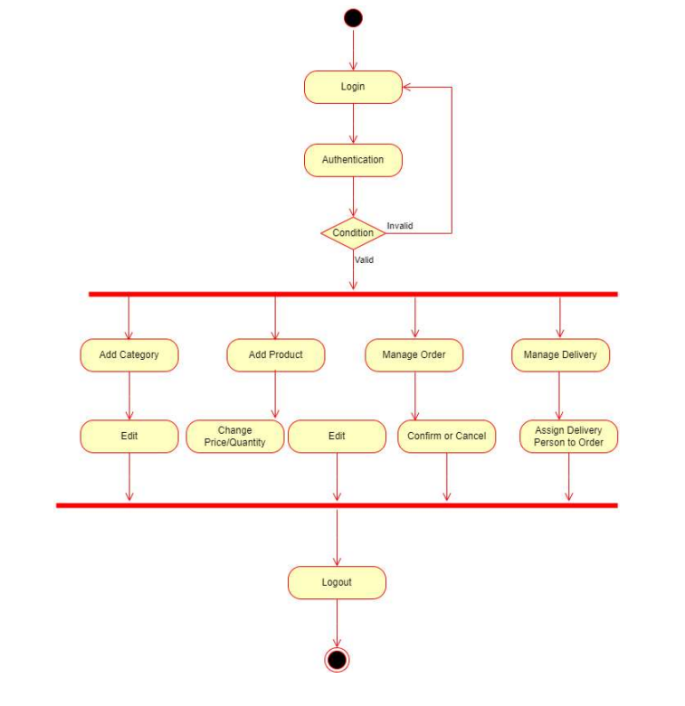

Figure: Activity Diagram Admin

**Activity Diagram User**

**USER**

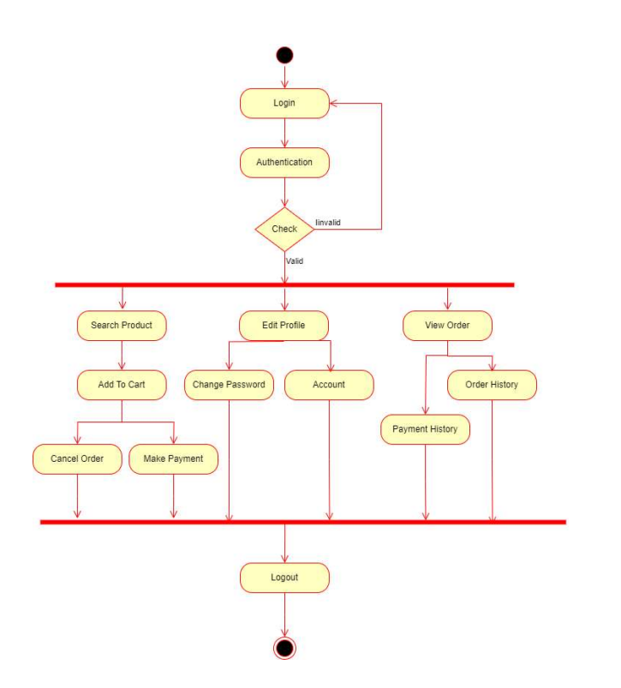

Figure: Activity Diagram User

* **Data Flow Diagrams**

LEVEL 0 DFD

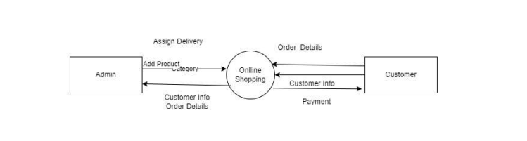

Figure: DFD level 0

LEVEL 1: ADMIN

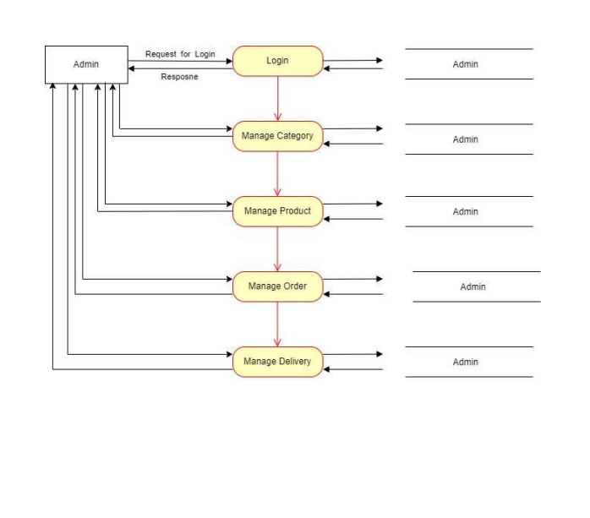

Figure: DFD level 1

LEVEL 1: CUSTOMER

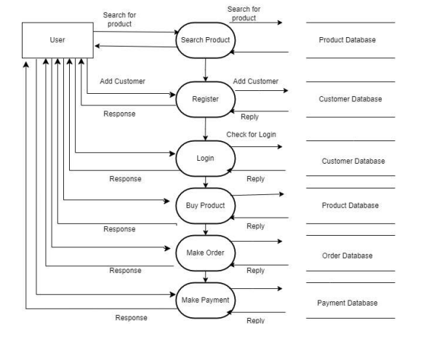

Figure: DFD level 1 (Customer)

* **Class Diagram**

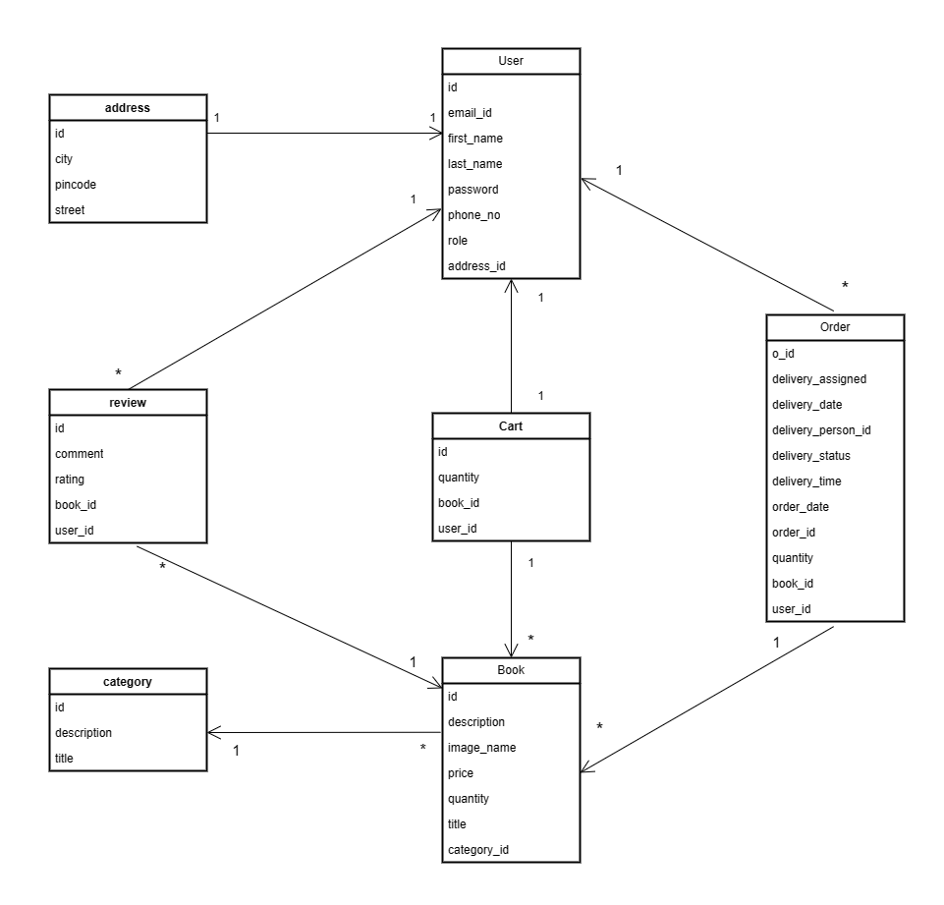

Figure: Class Diagram

* **Use Case Diagram**

1.ADMIN

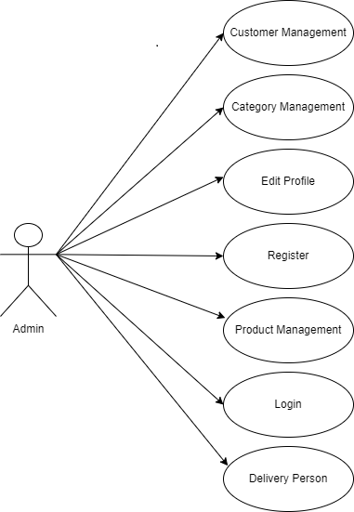

Figure: Use Case Diagram Admin

**2.Registed user**

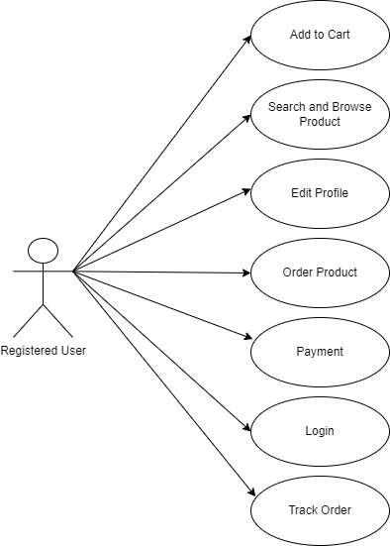

Figure: Use Case Diagram User

**3.Deliver person**

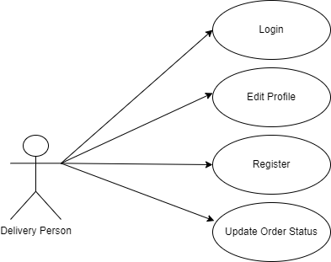

Figure: Use Case Diagram Delivery Person

**4.Guest User**

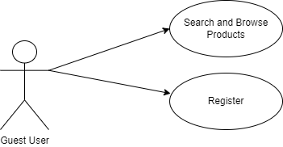

Figure: Use Case Diagram Guest User

* **ER Diagram**

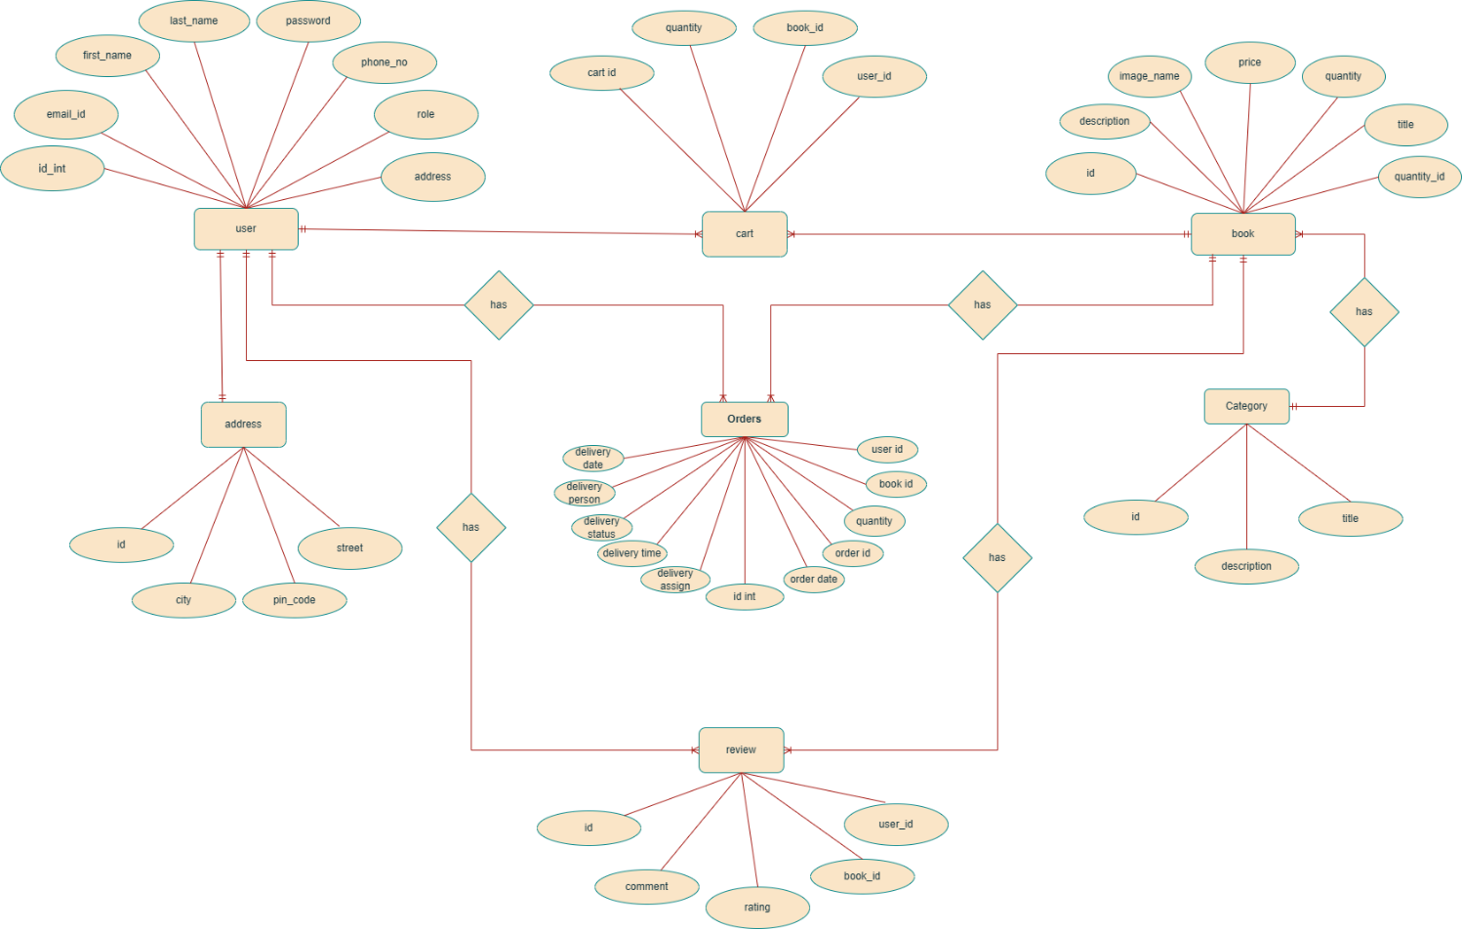

Figure: ER Diagram

**System Generated ERD**

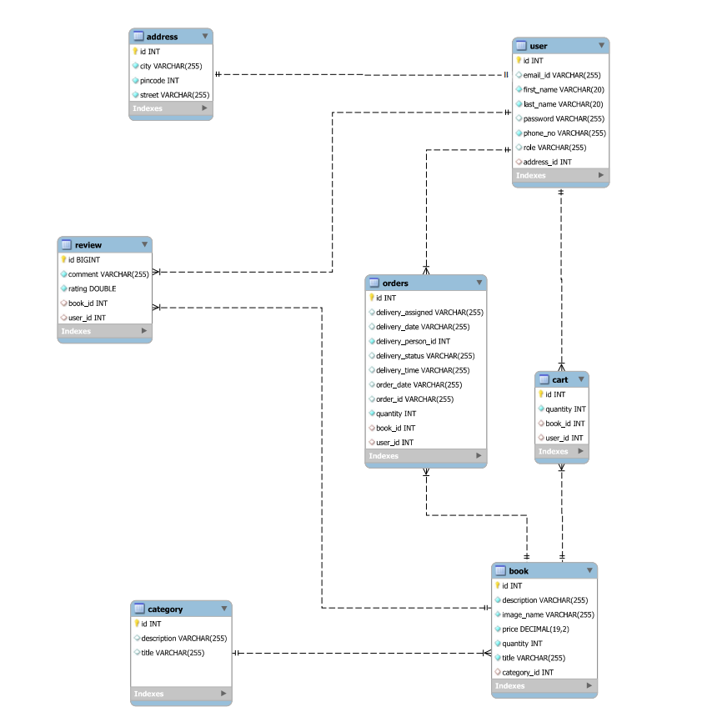

Figure: System Generated ER

**Sequence Diagram**

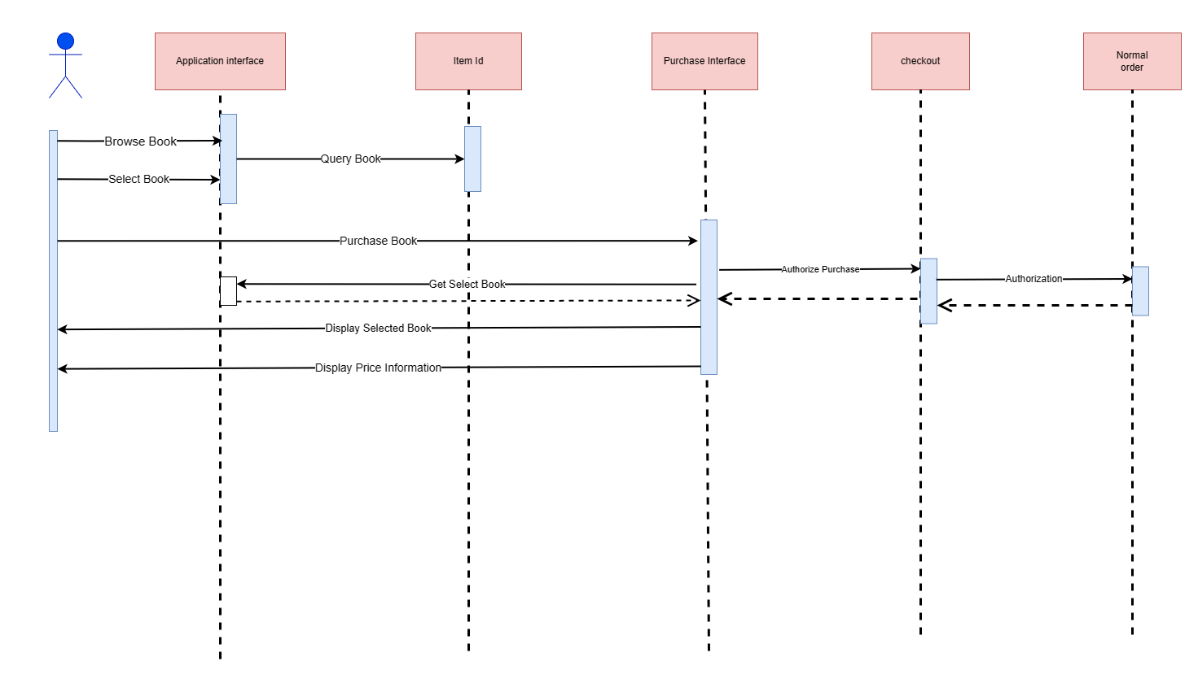

Figure: Sequence Diagram

**5.TABLE STRUCTURE**

**1.USER Table**

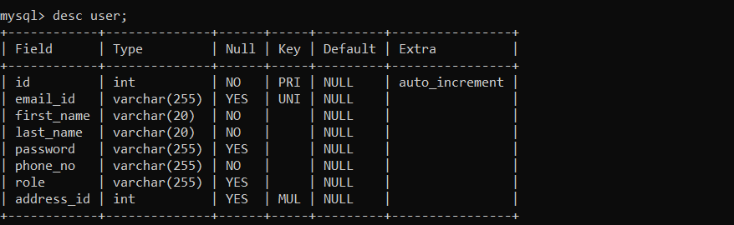

**2.Address Table**

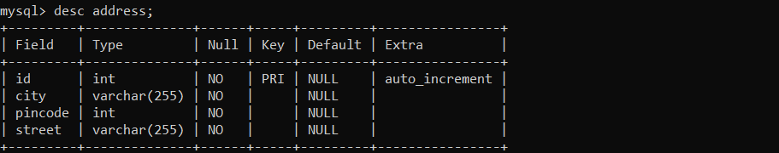

**3. Category Table**

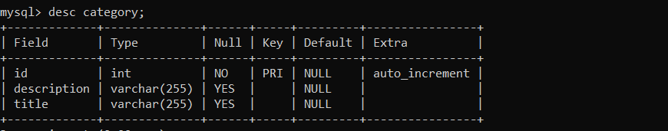

**4.Book Table**

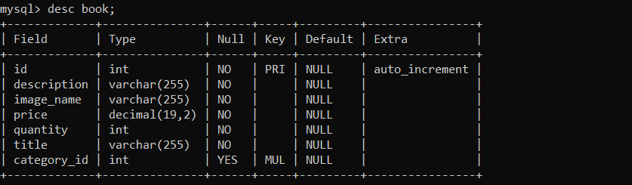

**5.Cart Table**

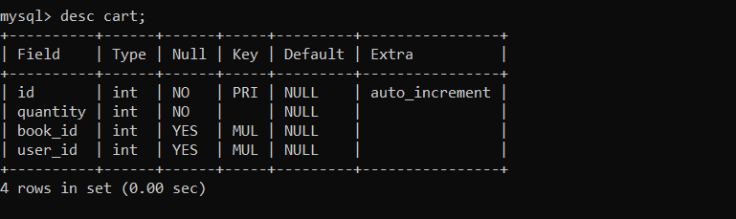

**6.Orders Table**

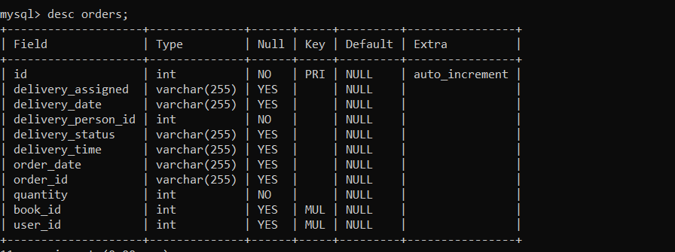

**7.Review Table**

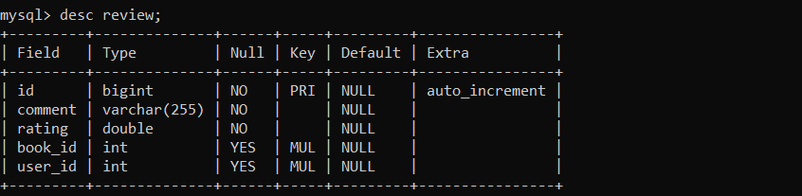

**6.SCREENSHOTS**

**HOME PAGE**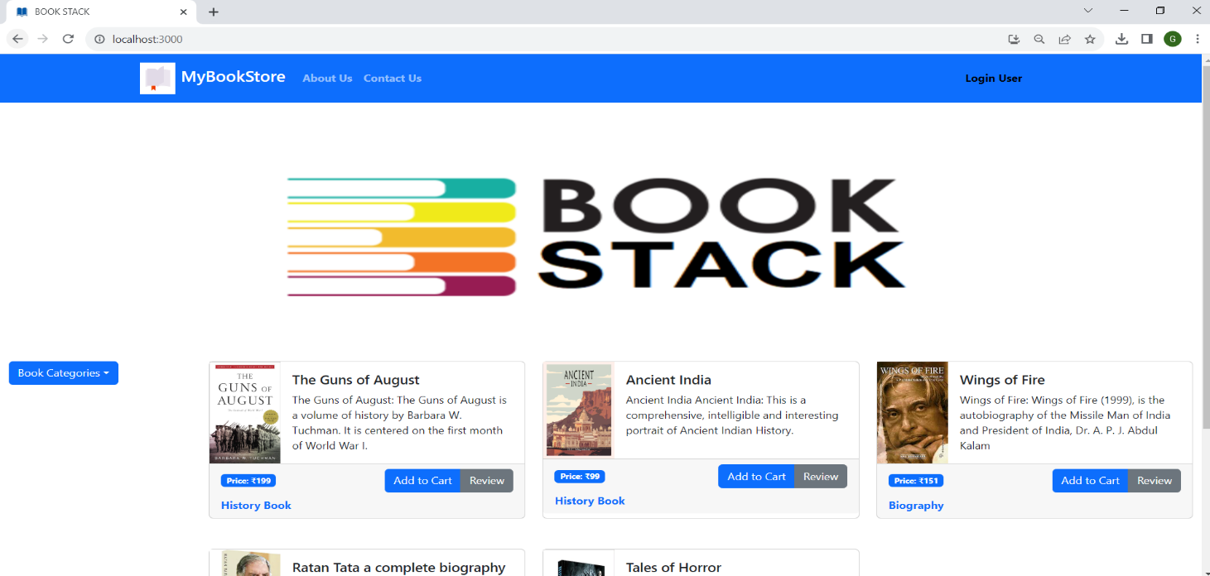

**SIGN UP PAGE** 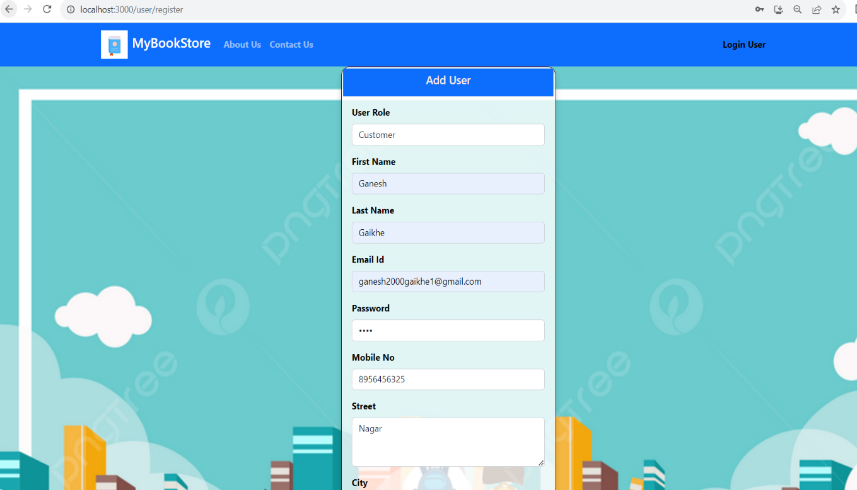

**LOGIN PAGE**

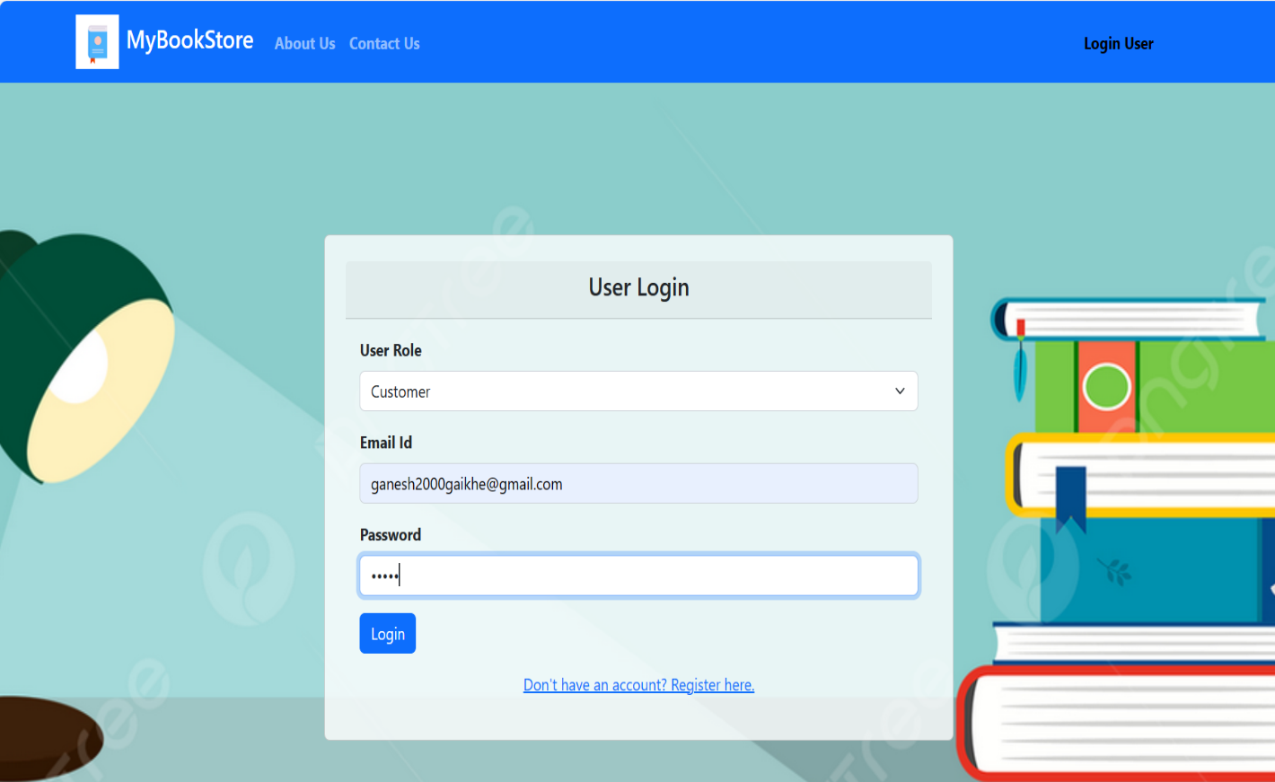

**ADMIN FRONT PAGE**

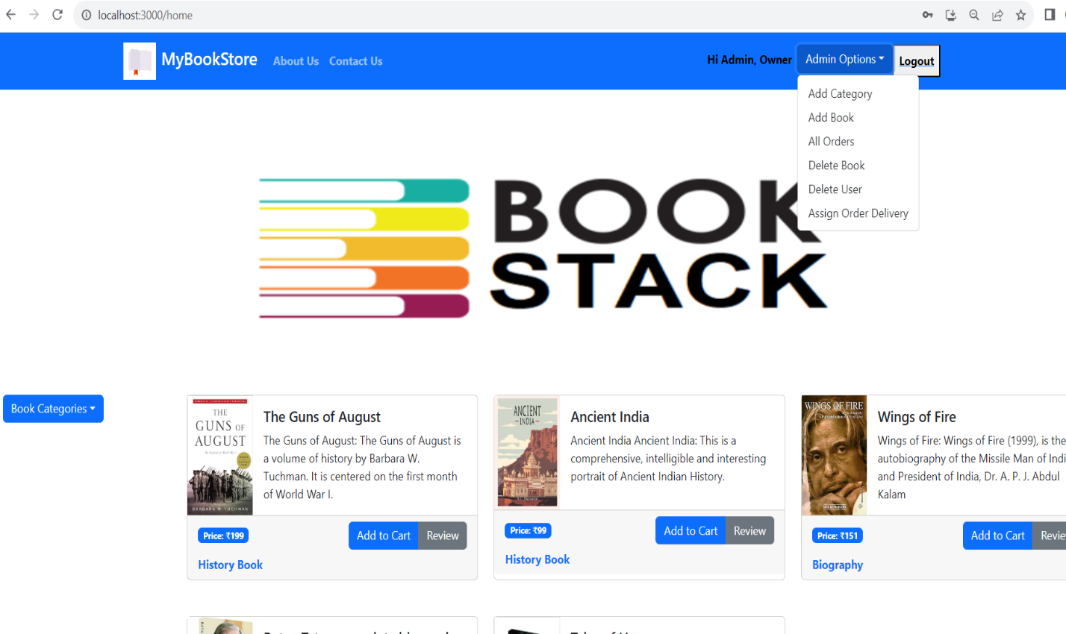

**ADMIN ADD BOOK**

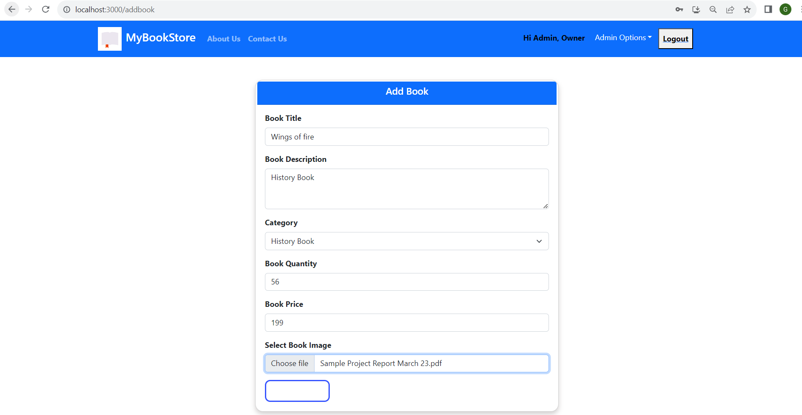

**ADMIN DELETE BOOK**

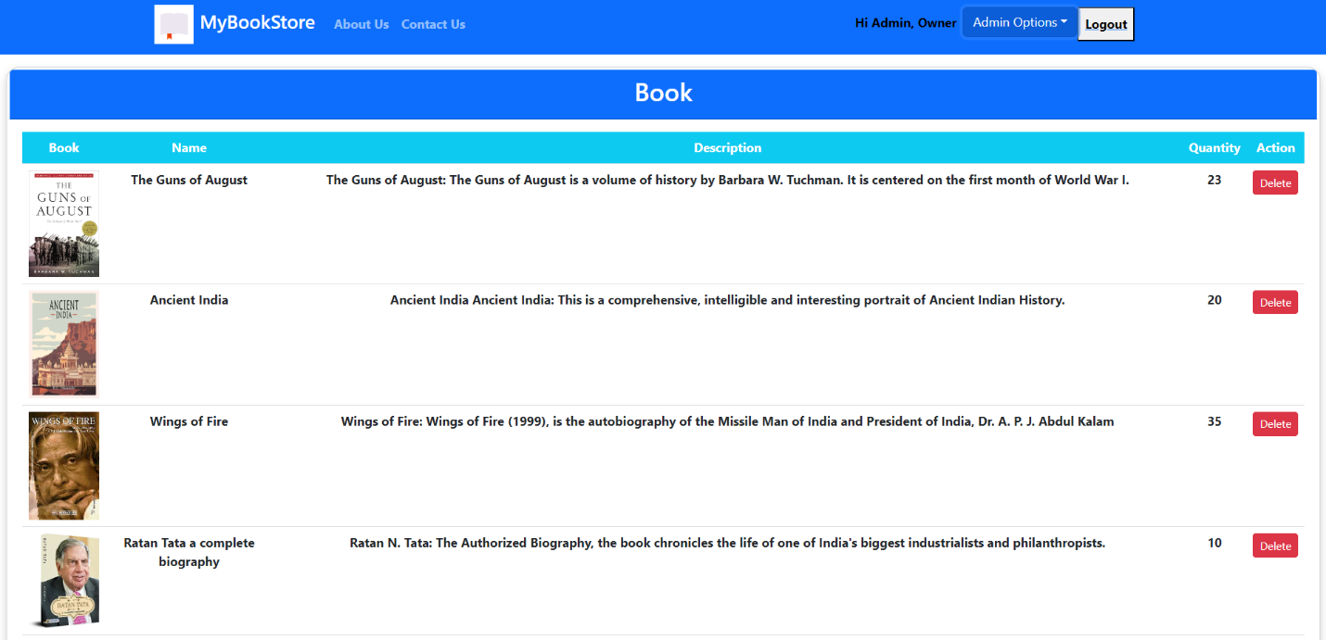

**ADMIN DELETE USER**

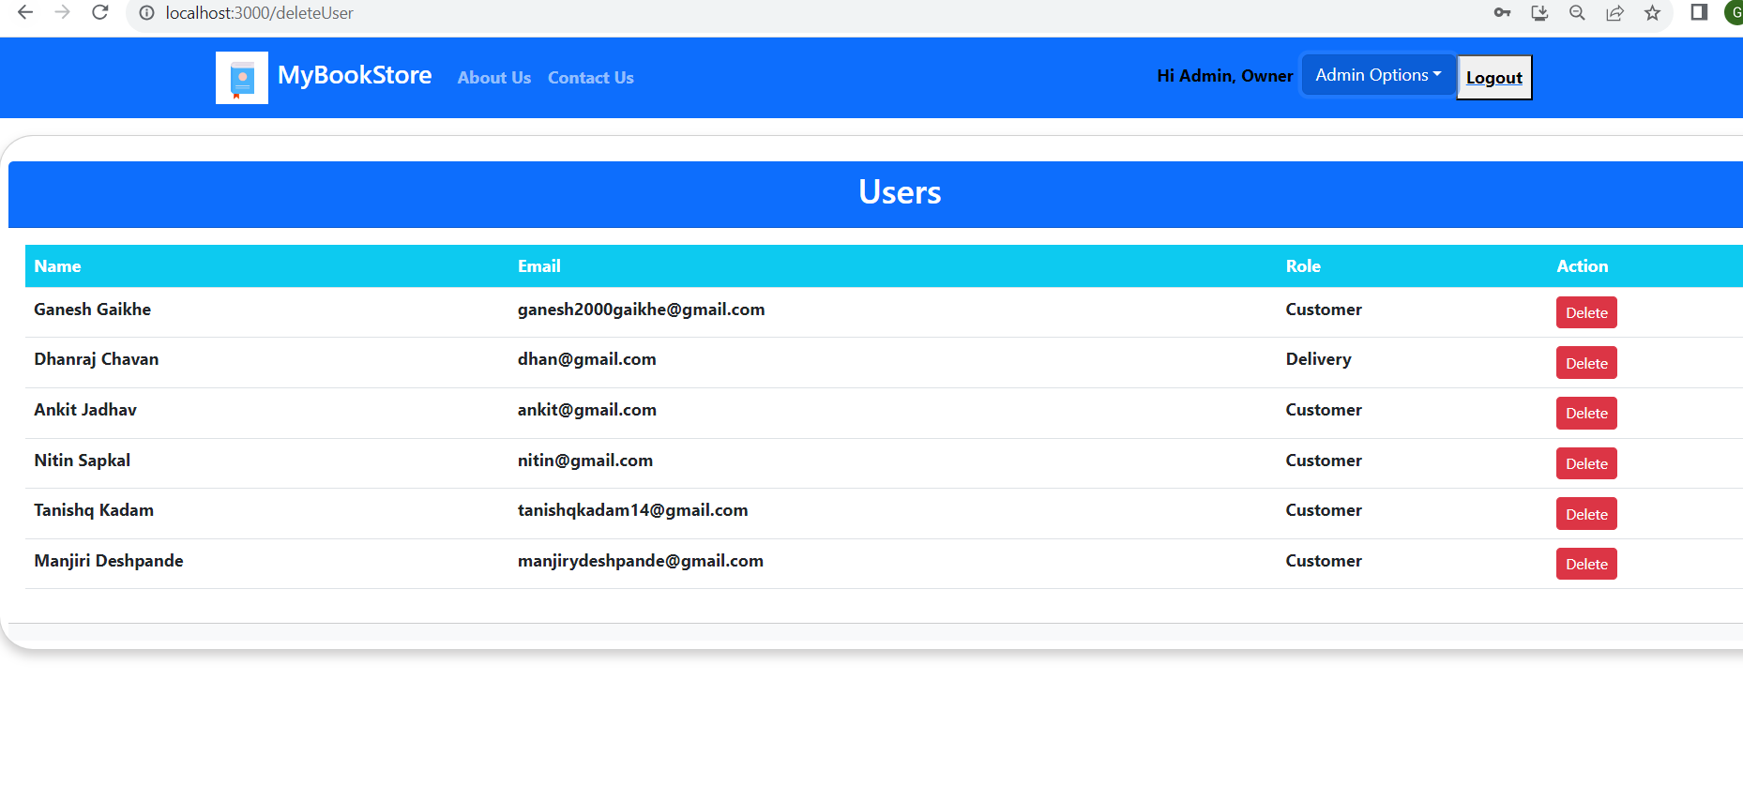

**ALL ORDERS SEEN BY ADMIN**

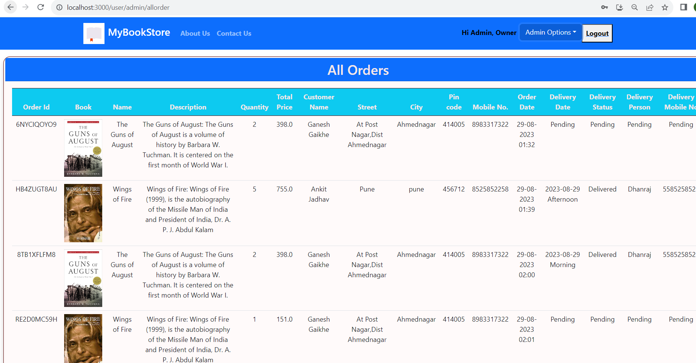

**FRONT PAGE OF REGISTER USER**

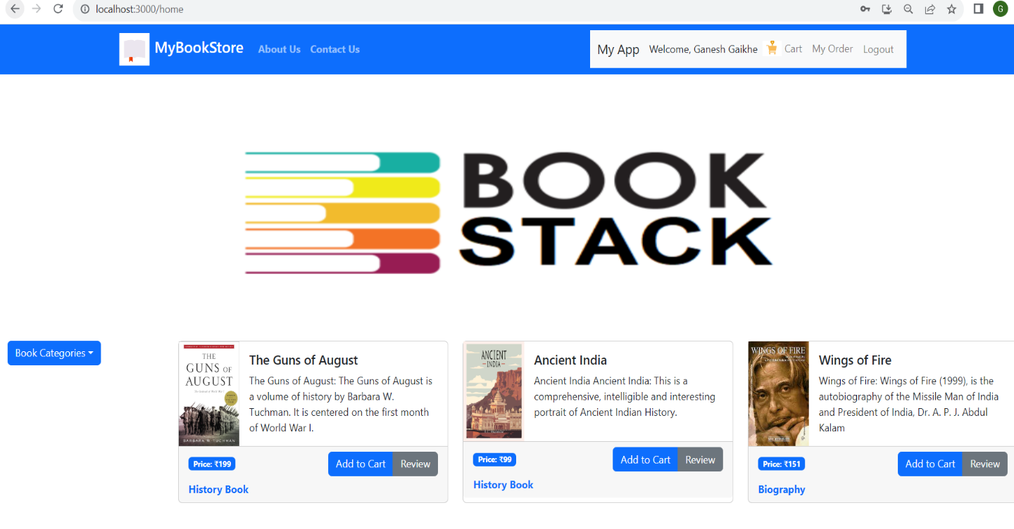

**CART OF CUSTOMER**

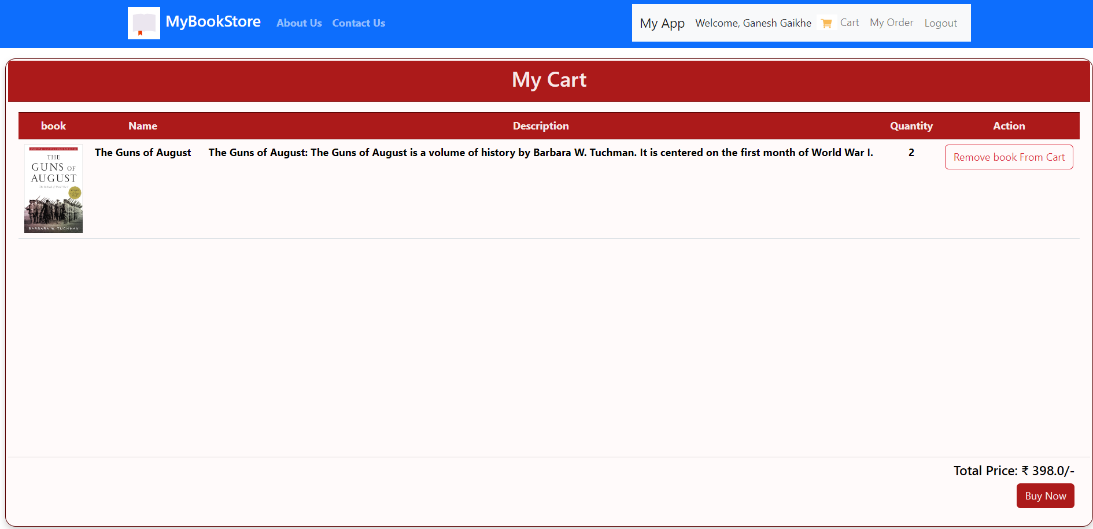

**ORDER OF CUSTOMER AFTER PAYMENT**

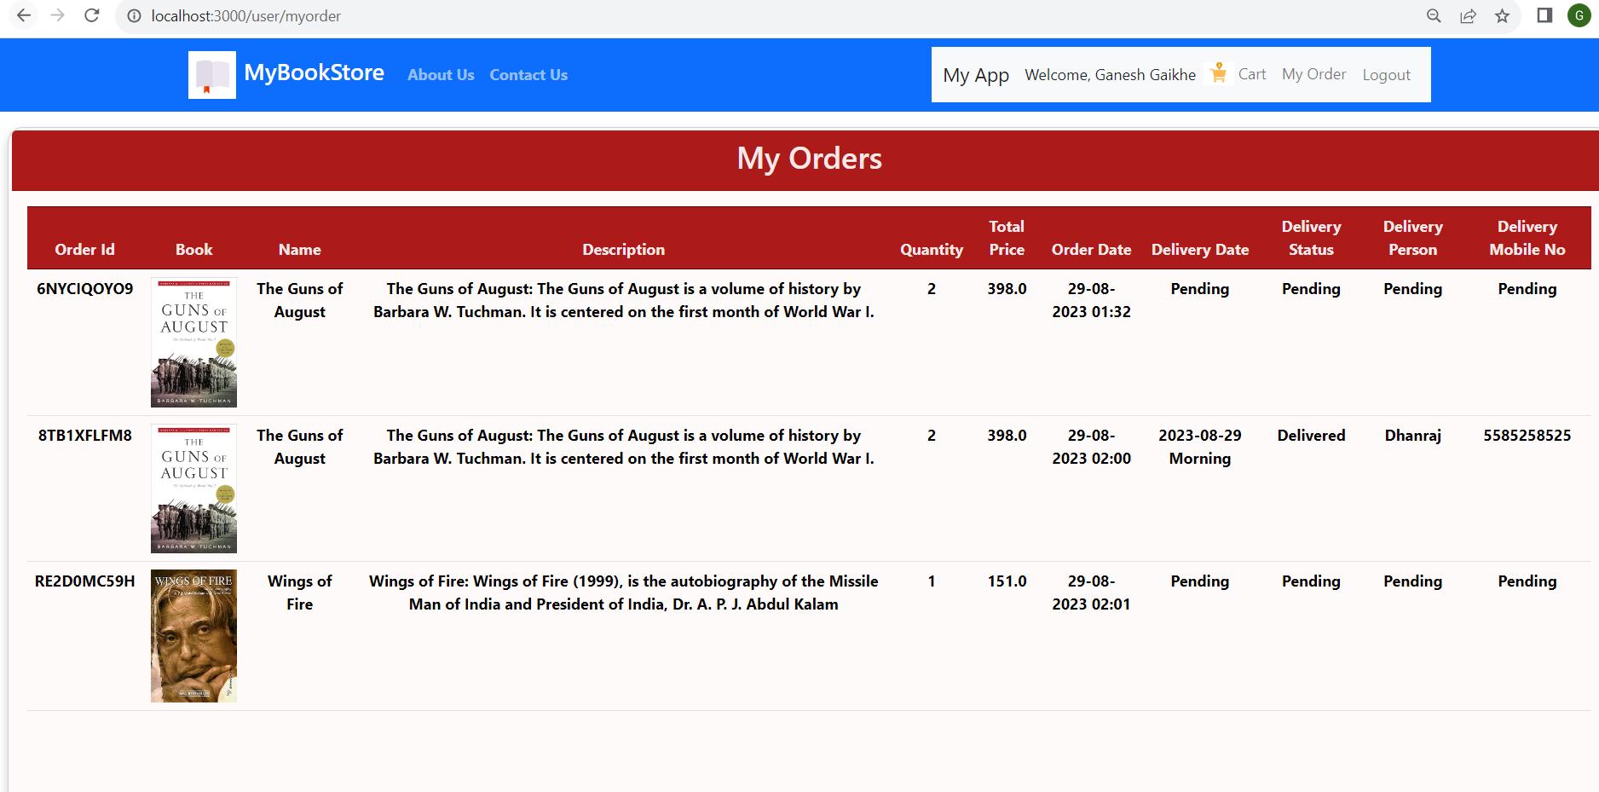

**ASSIGN DELIVERY PERSON BY ADMIN**

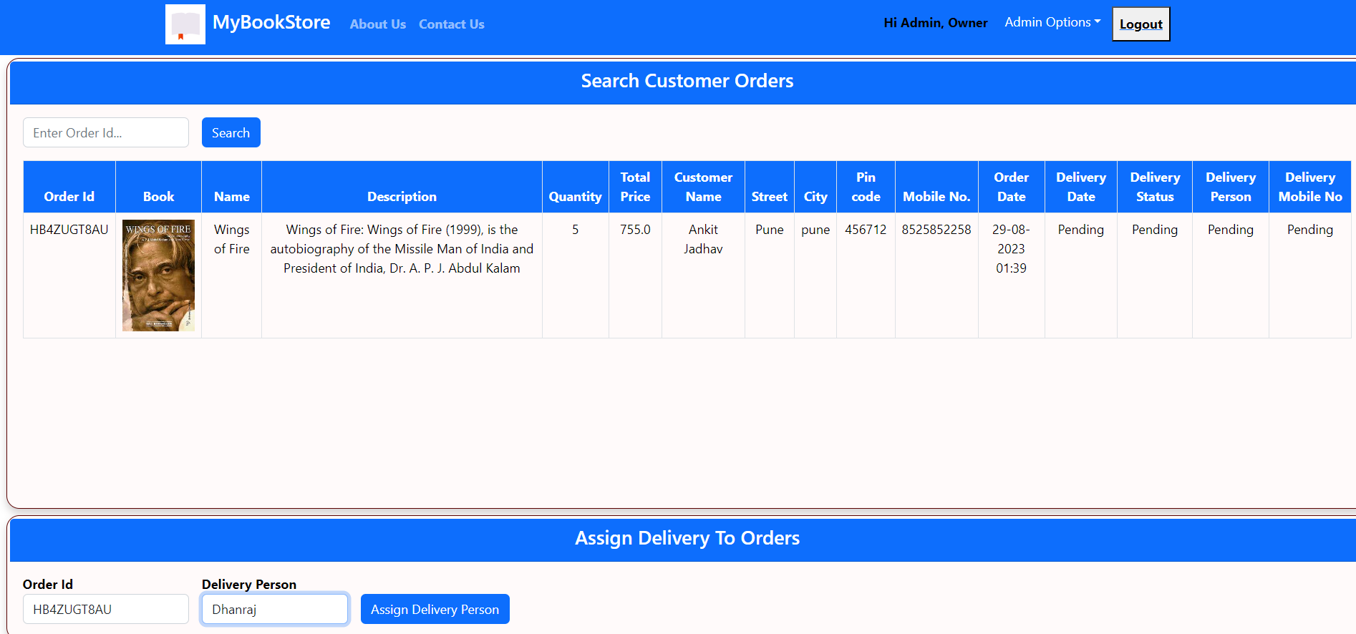

**Front Page of Delivery Person**

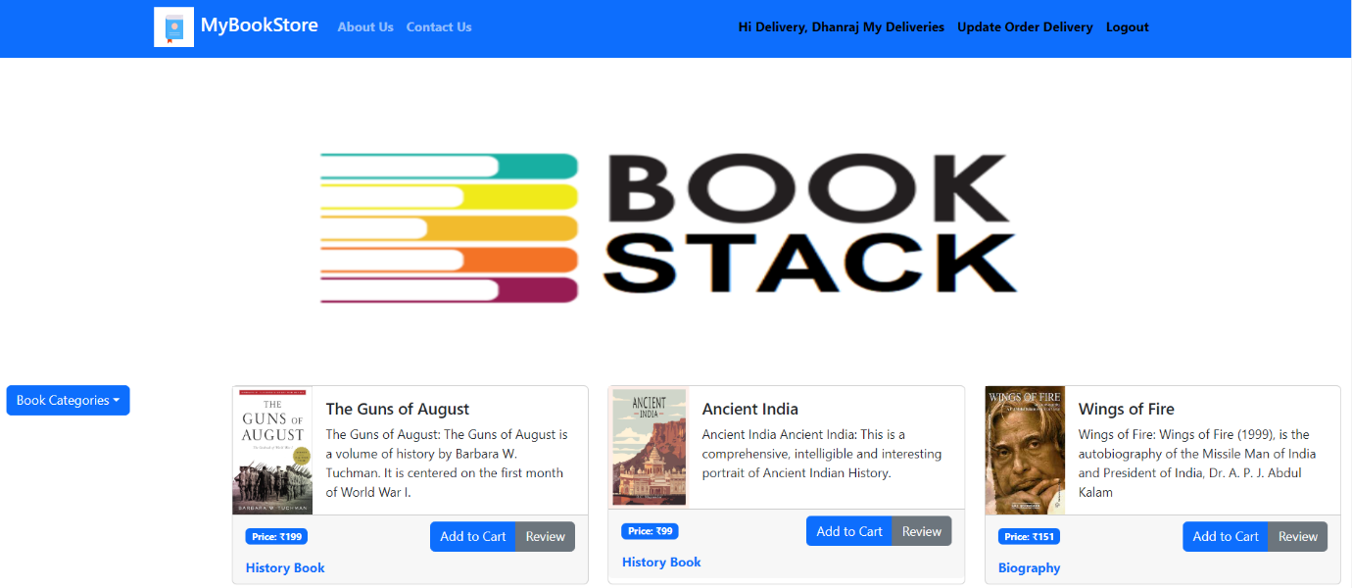

**Update Delivery Status**

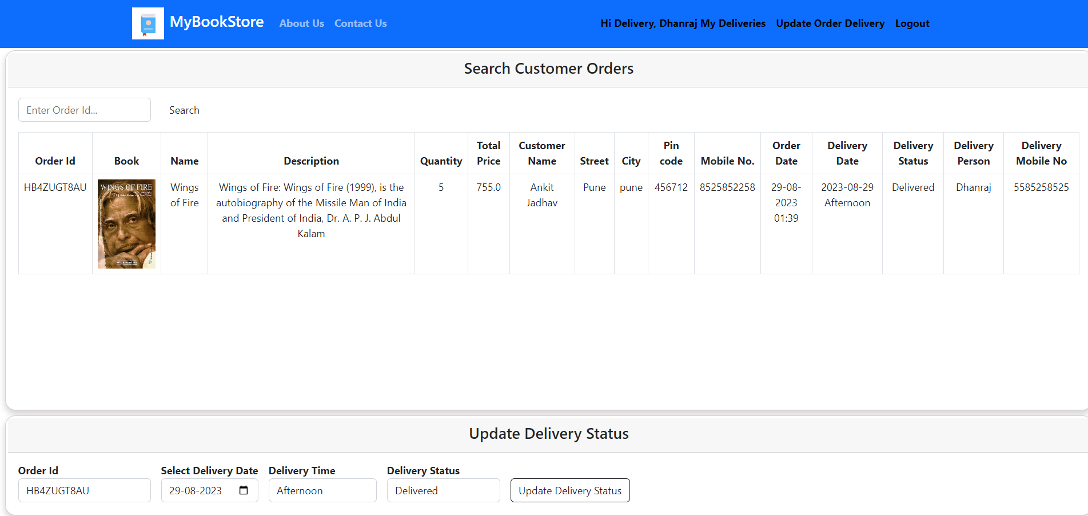

**PASSWORD ENCRYPTION**

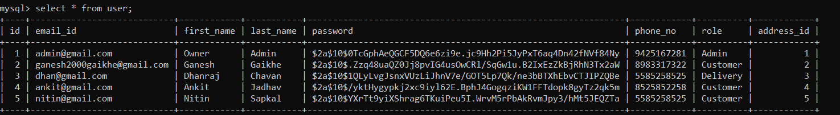

**MAIL**

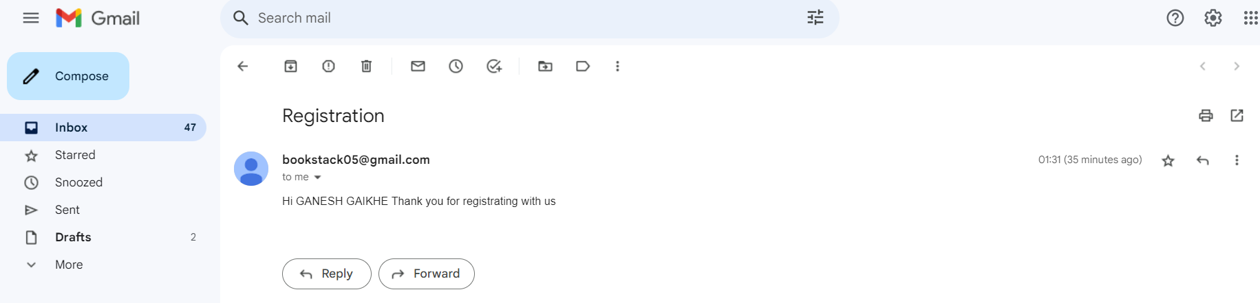

**7. CONCLUSION**

This system is a transformative force in the B2C landscape, simplifying communication and enhancing business operations. For owners, it's an all-encompassing solution that streamlines their roles. They can efficiently manage user interactions, oversee the entire application, and effortlessly schedule shifts. Moreover, it facilitates a seamless experience for members, enabling them to search for books, apply for memberships, and access workout information. This system also empowers administrators, granting them control over user management and the application's overall functionality.

Customer find immense value in this system, as it enables them to create schedules, devise personalized diet plans, and prescribe tailored workout routines. This level of customization enriches the customer experience and bolsters client satisfaction. In today's digital age, it also serves as a gateway for shop owners to expand their businesses online, saving both time and effort for customers while broadening revenue streams.

In summary, this system is a versatile and powerful solution, delivering efficiency, convenience, and growth opportunities to B2C businesses. It caters to the needs of owners, administrators, trainers, and customers alike, ensuring smooth operations and an exceptional user experience. Embrace this system to unlock new potential in the digital era of B2C commerce.

* **Future Scope:**

This project can be enhanced further by adding payment gateway to reduce the maintenance of cash for purchase books The software is flexible enough to be modified and implemented as per future requirements. We have tried our best to present this free and user–friendly website to shops.

**Integration of Payment Gateway:** As you rightly mentioned, integrating a secure payment gateway is a logical next step. This will not only reduce the reliance on physical cash for book purchases but also expand the revenue channels for shop owners.

**Enhanced User Experience:** Continuously improving the user interface and experience should be a priority. This could involve implementing personalized recommendations for book selections based on user preferences.

**Analytics and Reporting:** Introducing robust analytics tools can help shop owners gather valuable insights into customer behavior and sales trends.

**Security Enhancements:** As the platform grows, security becomes paramount. Regular security audits, data encryption, and user data protection measures should be incorporated to ensure the safety of user information and transactions.

**8.REFERENCES**

* **References:**
* [React – A JavaScript library for building user interfaces (reactjs.org)](https://reactjs.org/)
* [Bootstrap · The most popular HTML, CSS, and JS library in the world. (getbootstrap.com)](https://getbootstrap.com/)
* [React Tutorial (w3schools.com)](https://www.w3schools.com/react/)
* [**Java 11 Api docs**](https://docs.oracle.com/en/java/javase/11/docs/api/)
* [Spring Data JPA - Reference Documentation](https://docs.spring.io/spring-data/jpa/docs/current/reference/html/)